**Transmitting**

The transmission is really the same signal flow in the reverse direction. The mic has a bias resistor to allow for electret microphones. The output at the low pass filter is about -10dbm. The transmit power chain has a two 2N3904 broad band class A amps that boost the power to about +13 dbm level.

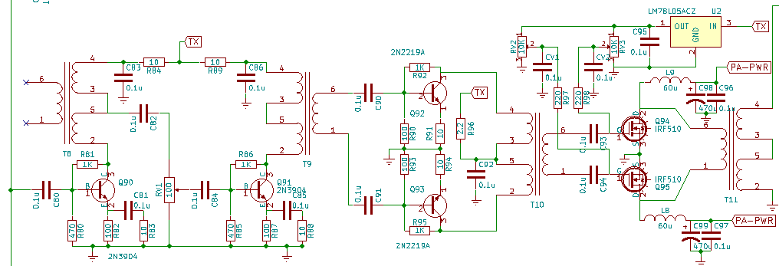

The power chain uses a little trick. The driver and the power amp stages are both in push-pull configuration. The push-pull amps cancel the even order harmonics significantly. Hence, a low pass filter cut for 7 Mhz with a notch at 10.5 Mhz can be used for 3.5 MHz and 7 Mhz simultaneously. Another filter similarly cut for 28 Mhz with a notch at 42 Mhz can be used for 14 MHz, 21 Mhz and 28 MHz. These are the more popular bands. For using the uBITX as a transmitter on other bands, external low pass filters have to be used.